PS-1603-X01 Firmware Specification

Revision | Date | Author | Comments
0.0 | 12/Jan/2021 | Chen Wu Heng  Huang Shuang Cai | Initial version

PS-1603-X01 FIRMWARE SPEC 1
1. DIAGRAM 3
2. TARGET MICRO-P REQUIREMENT 5
3. GENERAL MICRO-P PINOUT DESCRIPTION 5
4. I/O PINS 8
4.1 INPUT PINS 8
4.2 OUTPUT PINS 8
5. ANALOG TO DIGITAL MEASUREMENT 10
6. PROTECTION 11
6.1 PROTECTION TIMING AND PMBUS FLAG 12
6.1.1 BUS VOLTAGE 12
6.1.2 OTP 12
6.2 PROTECTION SETTING POINT 13
6.2.1 PROTECTION SETTING POINT FOR PMBUS CMD 13
6.2.2 UNIT_OFF POINT 13
6.3 PROTECTION RECOVER AND RECOVER DESCRIPTION 13
6.4 REPORTING UPDATE TIME 14
7. FLOWCHART 15
7.1 PRIMARY SIDE FLOW CHART 15
7.2 SECONADRY FLOW CHART DESCRIPTION 16
7.2.1 STATE_STANDBY 17
7.2.2 STATE_ONING 17
7.2.3 STATE_NORMAL 19
7.2.4 STATE_OFFING 20
7.2.5 STATE_LATCH 20
8. TIME SEQUENCE 21
8.1 PRIMARY NORMAL STATE TIME SEQUENCE 21
8.2 SECONDARY NORMAL STATE TIME SEQUENCE 21
8.2.1 FAULT STATE TIME SEQUENCE -> AC_LOST 27
8.2.2FAULT STATE TIME SEQUENCE -> PS_OFF TO PS_ON 27
8.2.3FAULT STATE TIME SEQUENCE -> PS_ON TO PS_OFF 27
8.2.4 FAULT STATE TIME SEQUENCE -> NORMAL TO FAULT ( FAULT_FLAG: FAN LOCK, OVP, UVP, OCP, OTP, FAN_LOCK AND STB_OVP,STB_UVP) 27
9. OHERT CONTROL 29
9.1 PMBUS COMMUNICATION 29
9.2 BOOTLOADER 29
9.3 FAN 29
9.4 LED DISPLAY 29
9.5 FW VERSION RULE 29
9.6 CALIBRATION 29

10. BLACK BOX FAULT LOGGING 30

ARCHITECTURE

Architecture with block diagram

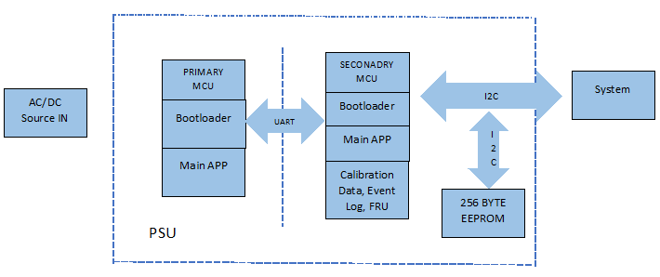

Architecture with Signals
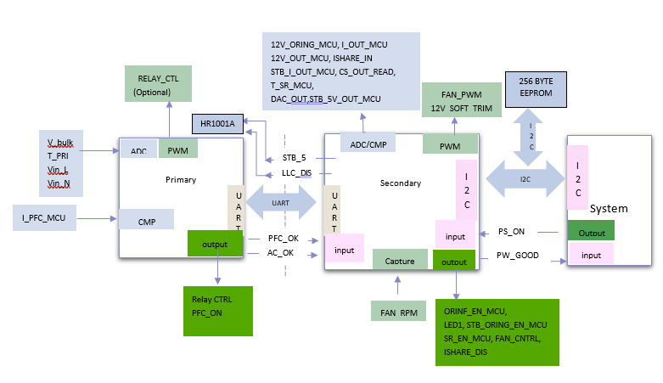

Main Program brief

Primary MCU Main Program
- Power ON/OFF Sequence Control
- Vac_Line, Vac_Neutral, Iac, Vbulk detection
- Inrush Current protection
- Brown out / in protection
- PFC OVP, UVP, OCP, OTP Protection
- PFC bus voltage output ON /OFF
- UART Inter communication
- Energy Calculation
- Calibration(optional)

Secondary MCU Main Program
- Power ON/OFF Sequence Control
- System Application (State machine)
- 12V and 5V STB OVP, UVP, OCP protection
- Current Sharing PID Control Loop
- Remote Sense
- LED Control
- FAN Control
- Temperature Sensor
- UART Inter communication
- I2C to EEPROM
- PMBUS communication
- Event Log Management
- Calibration & Relevant Data Management (Optional)

Target micro-P requirement
- Primary Microcontroller: Microchip DSPIC33EP32GS502
- Memory: 16 Kbyte
- Speed: 70 MIPS
- Watchdog: Enable

Secondary Microcontroller: Microchip dsPIC33EP64GS504T -I/ML
- Memory: 64 Kbyte
- Speed: 70 MIPS
- Watchdog: Enable

GENERAL MICRO-P PINOUT DESCRIPTION

Primary Pin assignment

Pin No | Pin Configuration | Pin Function | Pin Direction | PSU Signal / function | Details
1 | AN2 | Analog | Input | V_bulk | bulk vtg f/b
2 | AN3 | Analog | Input | I_PFC_MCU | PFC current for monitor and reporting
3 | AN4 | Analog | Input | T_PFC | Primary heatsink temperature
4 | AN5 | Analog | Input | VDC_MCU | Vbulk_sense
5 | Vss | POWER |  | 3V3_GND | POWER
6 | RB1 | GPIO | Output | PFC_OK_PRI( to sec) | AC OK signal to sec MCU
7 | RB2 | GPIO | Output | AC_OK_PRI ( to sec) | PFC OK signal to sec MCU
8 | RP35 | Uart | Input | PRI_RX | Communication with secondary MCU
9 | RP36 | Uart | Output | PRI_TX | Communication with secondary MCU
10 | VDD | POWER |  | 3V3_P | POWER
11 | RB8 | GPIO | Input | TP | TEST_POINT
12 | RB15 | GPIO | Output | LED1 | Status Indicator
13 | RB5 | GPIO | Output | DEBUG | DEBUG
14 | PGED1 | Programming | In/Out | PGED1 | Programming
15 | PGEC1 | Programming | Output | PGEC1 | Programming
16 | Vss | POWER |  | 3V3_PVSS | POWER
17 | Vcap | Cap | MCU Capacitor |  | MCU Capacitor
22 | PWM1H/RA4 | PWM/GPIO | Output | Relay CTRL | Inrush Relay signal
23 | RA3 | GPIO | Output | PFC_ON_H | Enable PFC Signal
24 | AVss | POWER |  | 3V3_AGND | POWER
25 | AVDD | POWER |  | 3V3_P_A | POWER
26 | MCLR | MCU RESET | Input | MCLR_PRI | MCU RESET
27 | AN0 | Analog | Input | Vin_L | Input line voltage
28 | AN1 | Analog | Input | Vin_N | Input neutral vtg

Secondary MCU pin assignment

Pin No | Pin Configuration | Pin Function | Pin Direction | PSU Signal | Details
1 | PGEC1 | programming | Output |  | programming
2 | RC4 | GPIO | Input | PS_A1 | address Select
3 | RC5 | GPIO | Input | PS_A2 | address Select
4 | RC6 | GPIO | Input | PFC_OK_SEC | pfc status
5 | RC3 | GPIO | Input | PS_A0 | address Select
6 | Vss | POWER |  | 3V3_SGND | POWER
7 | Vcap | Cap |  | MCU Capacitor | MCU Capacitor
8 | RB11 | GPIO | Output | ORING_EN_MCU | ORing gate signal
9 | RB12 | GPIO | Output | POK | pok
10 | PWM2H | PWM | Output | 12V_SOFT_TRIM | 12V software trimming
11 | RB14 | GPIO | Input | FAN_SPEED | Measure FAN RPM
12 | PWM1H | PWM | Output | FAN_PWM | PWM control for FAN
13 | RA3 | GPIO | Input | PSON / REMOTE ON | ps on/off
14 | RC0 | GPIO | Input | AC_OK_SEC | ac ok signal from primary
15 | RC13 | GPIO | Output | LLC_DIS | LLC primary gate driver disable
16 | AVss | POWER |  | 3V3_Avss | POWER
17 | AVDD | POWER |  | 3V3_S_A | POWER
18 | MCLR | MCU RESET | Input | MCU RESET | MCU RESET
19 | RC11 | GPIO | Output | STB_ORING_EN_MCU | ENABLE STANDBY ORING
20 | RC12 | GPIO | Output | SR_EN_MCU | ENABLE SR
21 | AN0 | Analog | Input | 12V_ORING_MCU | output voltage before ORing
22 | AN1 | Analog | Input | I_OUT_MCU | PSU output current
23 | AN2 | Analog | Input | 12V_OUT_MCU | PSU output voltage
24 | AN3 | Analog | Input | ISHARE_INT | current share internal voltage
25 | AN4 | Analog | Input | STB_5V_OUT_MCU | 5V SB Voltage sense
26 | AN5 | Analog | Input | STB_I_OUT_MCU | standby current sense
27 | RP57 | UART | Input | SEC_RX | communication with primary MCU
28 | RP58 | UART | Output | SEC_TX | communication with primary MCU
29 | VDD | POWER |  | 3V3_S | POWER
30 | VSS | POWER |  | 3V3_S_vss | POWER
31 | RC1 | GPIO | Output | 12V_DROOP | output pwm
32 | AN6 | Analog | Input | CS_OUT_READ | Input ADC, for current share
33 | AN7 | Analog | Input | T_SR_MCU | SR heatsink temp sensing
34 | DACOUT1 | Analog | Ouput | DAC_OUT | DAC_OUT for current share
35 | RB4 | GPIO | Input | ISHARE_DIS | Current share disable
37 | ASDA1 | I2C | In/Out | PMBUS_SDA | Pmbus data line
38 | ASCL1 | I2C | Output | PMBUS_SCL | Pmbus clock line
39 | VSS | POWER |  | 3V3_S_Vss | POWER
40 | VDD | POWER |  | 3V3_S | POWER
41 | SDA2 | I2C | In/Out | I2C_EEPROM_SDA | EEPROM
42 | SCL2 | I2C | Output | I2C_EEPROM_SCL | EEPROM
43 | RB5 | GPIO | Output | LED1 | Status LED
44 | PGED1 | Programming | In/Out | PGED1 | programming

I/O PINS

Primary Side

OutPut PIN
Pin # | Pin name | Initial State | Connect to | I/O Level definition
6 | RB1 | L | PFC_OK_PRI | Logic 0 : PFC OK  Logic 1 : PFC Not OK
7 | RB2 | H | AC_OK_PRI | Logic 0 : AC OK  Logic 1 : AC Not OK
22 | RA4 | H | Inrush Relay CTRL | Logic 0: ON  Logic 1: OFF
23 | RA3 | L | PFC_ON | Logic 0 : Disable  Logic 1 : Enable

ANALOG TO DIGITAL MEASUREMENT
Pin # | Pin Name | Connect to | Scale
1 | AD2 | V_bulk | 0Vi/0V ~ 472Vi/3.3V
2 | AD3 | I_PFC_MCU | 0Vac/0V ~ 321Vac/3.3V  or  0Vdc/0V ~ 454Vdc/3.3V
3 | AD4 | T_PRI | ? 10K NTC
27 | AN0 | Vin_L | 0Vac/0V ~ 295Vac/3.3V
28 | AN1 | Vin_N | 0Vac/0V ~ 295Vac/3.3V

Secondary Side

Input pins

Pin # | Pin name | Connect to | I/O Level definition
2 | RC4 | PS_A1 | Logic 0: I2C address value for zero  Logic 1: I2C address value for one
3 | RC5 | PS_A2 | Logic 0: I2C address value for zero  Logic 1: I2C address value for one
4 | RC6 | PFC_OK_SEC | Logic 0: PFC OK  Logic 1: PFC NOT OK
5 | RC3 | PS_A0 | Logic 0: I2C address value for zero  Logic 1: I2C address value for one
13 | RB5 | PSON | Logic 0: PS_OFF  Logic 1: PS_ON
14 | RA3 | AC_OK__SEC | Logic 0: AC GOOD  Logic 1:AC NOT GOOD

4.2.2 OUTput pins
Pin # | Pin name | Initial State | Connect to | I/O Level definition
8 | RB11 | L | ORINF_EN_MCU | Logic 0: Oring disable  Logic 1: Oring enable
9 | RB12 | L | PW_GOOD | Logic 0: Power not Good  Logic 1: Power Good
15 | RC13 | L | LLC_DIS | Logic 0: LLC IC disable  Logic 1: LLC IC enable
43 | RB5 | L | LED1 | Logic 0: No AC power available  Blinking: AC Present / +5VSB on  (Main DC Output OFF)  Logic 1: Power Supply ON and OK
19 | RC11 | L | STB_ORING_EN_MCU | Logic 0: standby oring disable  Logic 1: standby oring enable
20 | RC12 | L | SR_EN_MCU | Logic 0: SR disable  Logic 1: SR enable
36 | RC2 | L | FAN_CNTRL | Logic 0: FAN disable  Logic 1: FAN enable
35 | RB4 | L | ISHARE_DIS | Logic 0: Disable current sharing  Logic 1: Enable current sharing

ANALOGUE pins
Pin # | Pin Name | Connect to | Scale
21 | AN0 | 12V_ORING_MCU | 0V/0Vdc ~ 16.23V/3.3Vdc
22 | AN1 | I_OUT_MCU | 0A/0V ~ ? 60A/3.3V
23 | AN2 | 12V_OUT_MCU | 0V/0Vdc ~ 16.23V/3.3Vdc
24 | AN3 | ISHARE_IN | 0A/0V ~ ? 10.584V/3.3V
25 | AN4 | STB_5V_OUT_MCU | 0A/0V ~ 6V/3.3V
26 | AN5 | STB_I_OUT_MCU | 0A/0V ~ 0.5A/3.3V
32 | AN6 | CS_OUT_READ | 0A/0V ~ ? A/3.3V
33 | AN7 | T_SR_MCU | 10K NTC
34 | AN18 | DACOUT1 | DAC_OUT
- Resolution: 12-bits, reference voltage 3.3V.

PWM PINs
Pin # | Pin Name | Connect to | Description
12 | PWM1H | FAM_PWM
22 | PWM2H | 12V_SOFT_TRIM
 |  | 12V_DROOP

5. A/D Detection Method

AC input

AC Slow-Speed detection
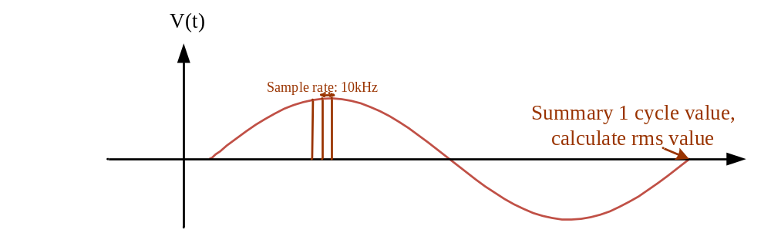
- x₁、x₂... x_{n} are sampling points in one period of input AC source and captured in the fixed rate (sampling frequency fs is 10kHz )
- Estimated voltage in Peak value is calculated by Vin.

DC INPUT
- Digital filter, Sample rate: ? 2kHz
- PFC bus low pass filter: ? 100Hz

PFC output
- Digital filter, Sample rate: ? 2kHz
- PFC bus low pass filter: ? 100Hz

PROTECTION

PFC Protection

BUS Voltage
Bus Detection | FW Delay Time | Value | Protect
PFC Bus voltage – OVP - Low | 120ms | 450v | Disable PFC_OK, PFC disable ,Latch PFC and 12 main Vout
PFC Bus voltage – OVP - High | 2ms | 460v | Disable PFC_OK, PFC disable ,Latch PFC and 12 main Vout
PFC Bus voltage – UVP - Drop | 1ms | 335/330v | Disable PFC_OK, auto restart

OTP
Temp Detection | Delay time | Value | Recovery Value | Protect
PFC Over temp | 10s | 110C | 60C | Disable PFC_OK, wait Recovery value

Input Voltage
Input Detection | Delay time | Value | Recovery Value | Protect
Vin OVP - AC | 72ms | 295V | 264V | PFC Relay Turn off, PFC not OK, PFC disable. Auto Restart.
Vin UVP - AC | 2ms | 74.55 V | 85.84V | PFC Relay Turn off, PFC not OK, PFC disable. Auto Restart.
Vin OVP - DC | 72ms | 310V | 288V | PFC Relay Turn off, PFC not OK, PFC disable. Auto Restart.
Vin UVP - DC | 2ms | 110V | 125V | PFC Relay Turn off, PFC not OK, PFC disable. Auto Restart.
- PFC Recovery time please ref. to 8. PFC START TIME SEQUENCE

Protection Timing and PMbus Flag

Page 0
Event | 12V main output shut down once trigger | 12V Can Auto recovery once the condition return to normal | 79H | 7AH | 7BH | 7CH | 7DH | 7EH | 81H | Event trigger --> Bit assert (unmask) | Event trigger --> SMBAlert assert (unmask) | Event trigger --> PSU shut down
12V OVP | YES | NO | 8860 | C0 | 00 | 00 | 00 | 00 | 00 | 40us | 40us | 45us
12V OCP | YES | NO | 4850 | 00 | A0 | 00 | 00 | 00 | 00 | 1.2 s | 1.2 s | 1.2 s
12V UVP | YES | NO | 8840 | 30 | 00 | 00 | 00 | 00 | 00 | 1.2 s | 1.2 s | 1.2 s
FAN FAULT | YES | NO | 0C40 | 00 | 00 | 00 | 00 | 00 | 80 | 15 s | 15 s | 15 s
FAN Override | NO | YES | 0000 | 00 | 00 | 00 | 00 | 00 | 08 | 1s | 1s | 1s
AC INPUT UVP | YES | YES | 2848 | 00 | 00 | 30 | 00 | 00 | 00 | 0.5~ 0.6 sec | 0.5~ 0.6 sec | 0.5~ 0.6 sec
AC INPUT OVP | YES | YES | 2840 | 00 | 00 | C0 | 00 | 00 | 00 | 4~6 AC cycle | 4~6 AC cycle | 4~6 AC cycle

Page 1
Event | 12V main output shut down once trigger | 12V Can Auto recovery once the condition return to normal | 79H | 7AH | 7BH | 7CH | 7DH | 7EH | 81H | Event trigger --> Bit assert (unmask) | Event trigger --> SMBAlert assert (unmask) | Event trigger --> PSU shut down
OTP1 | YES | YES | 0844 | 00 | 00 | 00 | C0 | 00 | N/A | 5 s | 5 s | 5 s
OTP2 | YES | YES | 0846 | 00 | 00 | 00 | C0 | 00 | N/A | 5 s | 5 s | 5 s
Standby Fault  (5Vstb OVP) | YES | YES | 8860 | C0 | 00 | 00 | 00 | 00 | N/A | 20us | 20us | 20us
Standby Fault  (5Vstb UVP) | YES | YES | 8840 | 30 | 00 | 00 | 00 | 00 | N/A | 120 ms | 120 ms | 120 ms
Standby Fault  (5Vstb OCP) | YES | YES | 4850 | 00 | 80 | 00 | 00 | 00 | N/A | 120 ms | 120 ms | 120 ms

Protection Setting Point

Protection Setting Point For PMBus CMD
Command code | Warning & Fault | FW default value | HW default value
0x40 (VOUT_OV_FAULT_LIMIT) | Vout OV FAULT | DC: 13.5 V | N/A
0x4A (IOUT_OC_WARN_LIMIT) | Iout OC warning | DC: 50.4A | N/A
0x46 (IOUT_OC_FAULT_LIMIT) | Iout OC fault | DC: 52.8A | N/A
 | Constant Current Limit | N/A | 54A
 | 5VSB OVP | DC: 5.91 | DC: 6.13 V
 | 5VSB OVW | DC: 5.63 | N/A
 | 5VSB UVP | DC: 4.46 | N/A
 | 5VSB OCP | DC: ? 0.8 A | N/A
 | 5VSB OCW | DC: ? 0.6A | N/A
0x51 (OT_WARN_LIMIT, PAGE1) | OT warning (Ambient) | Ambient OT warning: 55 C | N/A
0x51 (OT_WARN_LIMIT, PAGE0) | OT warning (Hotspot) | Hotspot OT warning: 100 C | N/A
0x4F (OT_FAULT_LIMIT, PAGE1) | OTP (Ambient) | Ambient OT Fault: 67 C | N/A
0x4F (OT_FAULT_LIMIT, PAGE0) | OTP (Hotspot) | Hotspot OT warning: 110 C | N/A
 | OTP recovery (Ambient) | Ambient OT Recovery: 52 C | N/A
 | OTP recovery (Hotspot) | Hotspot OT Recovery: 80 C | N/A
 | Fan Fault | FAN RPM < 500 RPM, | N/A

UNIT_OFF Point
Recovery point same as Vin_UV_fault and Vin_OV_fault recovery point.

Status_Input (7CH) | FW default value
UNIT_OFF (UV) | AC:74.55 Vac
UNIT_OFF (OV) | AC: 295 Vac

Protection Recover and Alert Recover Description
Event | Recovery  Method | After Recovery,  12V turn on time
12V OVW | Clear Fault(0x03), PS_ON_OFF | -
12V OCW | Clear Fault(0x03), PS_ON_OFF | -
12V OVP | PS_ON_OFF | Follow PS_ON_OFF startup time
12V OCP | PS_ON_OFF | Follow PS_ON_OFF startup time
12V UVP | PS_ON_OFF | Follow PS_ON_OFF startup time
OTW 1 | Clear Fault(0x03), PS_ON_OFF | -
OTP1 | Back to recover temp, but  Fault flag clear only by Clear Fault(0x03) | 3 sec
OTW2  (2nd hot-spot) | Clear Fault(0x03), PS_ON_OFF | -
OTP2  (2nd hot-spot) | Back to recover temp, but  Fault flag clear only by Clear Fault(0x03) | 3 sec
FAN FAULT | PS_ON_OFF | Follow PS_ON_OFF startup time
Standby Fault  (5Vstb OVP) | Back to recover voltage | until fault clear, every 5sec retry.
Standby Fault  (5Vstb UVP) | Back to recover voltage | until fault clear, every 5sec retry.
Standby Fault  (5Vstb OCP) | Back to recover current | until fault clear, every 5sec retry.
AC INPUT UVW | Clear Fault(0x03), PS_ON_OFF | -
AC INPUT UVP | Back to recovery voltage | 0.4s~0.9s
AC INPUT OVP | Back to fault recovery voltage | 0.4s~0.9s
AC INPUT OVW | Clear Fault(0x03), PS_ON_OFF | -

Reporting Update Time
Report Item | Update Time (s) | Accuracy (%)
Vin | 20 ms | +/-5%
Iin | 640 ms | +/-5%
Pin | 160 ms | +/-5%
Vout | 10.24 ms | +/-5%v
Iout | 163.84 ms | +/-5%
Pout | 163.84 ms | +/-5%
Tinlet | 640 us | +/-5°C
Tpri | 250 ms | +/-5°C
Tsec | 640 us | +/-5°C
Fan | Updated every cycle | +/-5%

FLOWCHART

PROMARY SIDE FLOW CHART
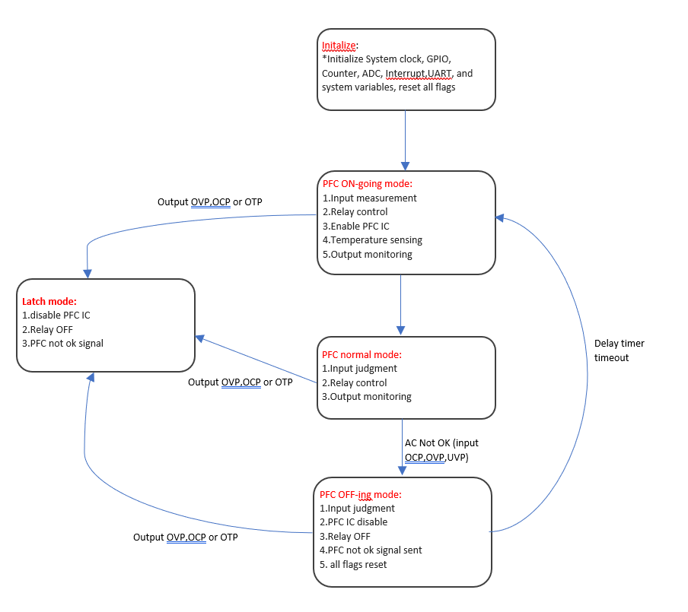

Secondary flowchart overview
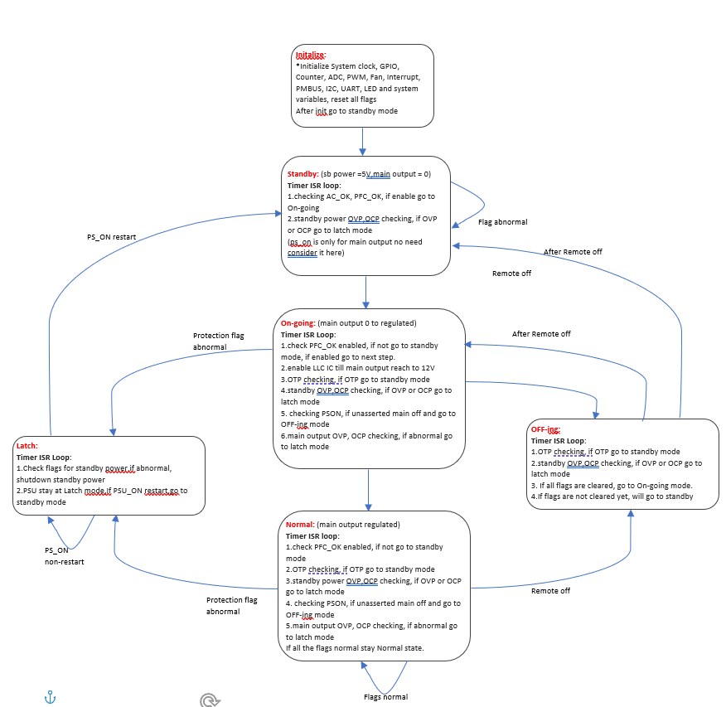

state_standby
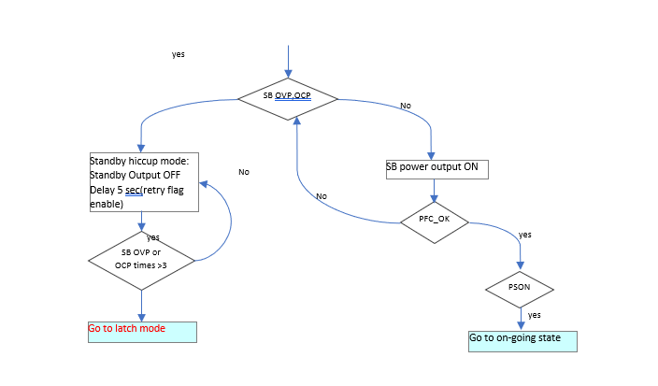

state_ONING

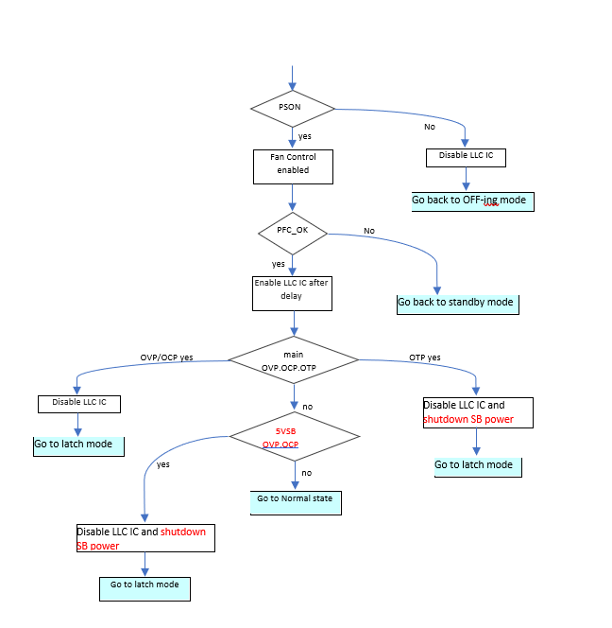

state_NORMAL

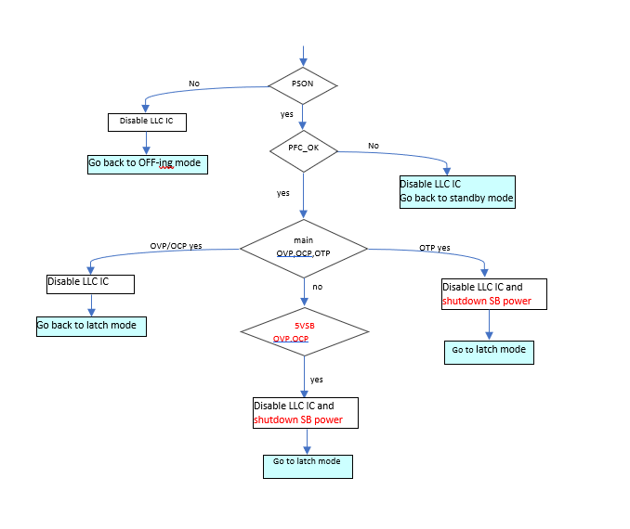

STATE_OFFING
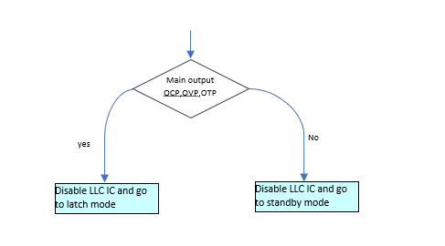

STATE_latch
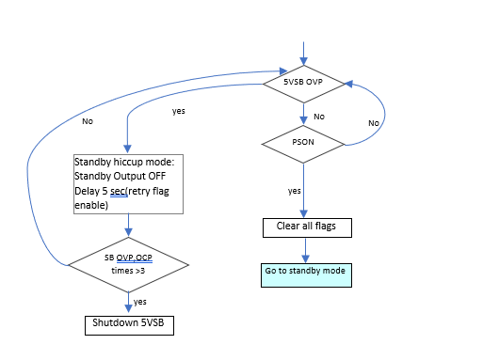

TIME SEQUENCE

Primary Normal State Time SequenCE with AC/DC ON /OFF
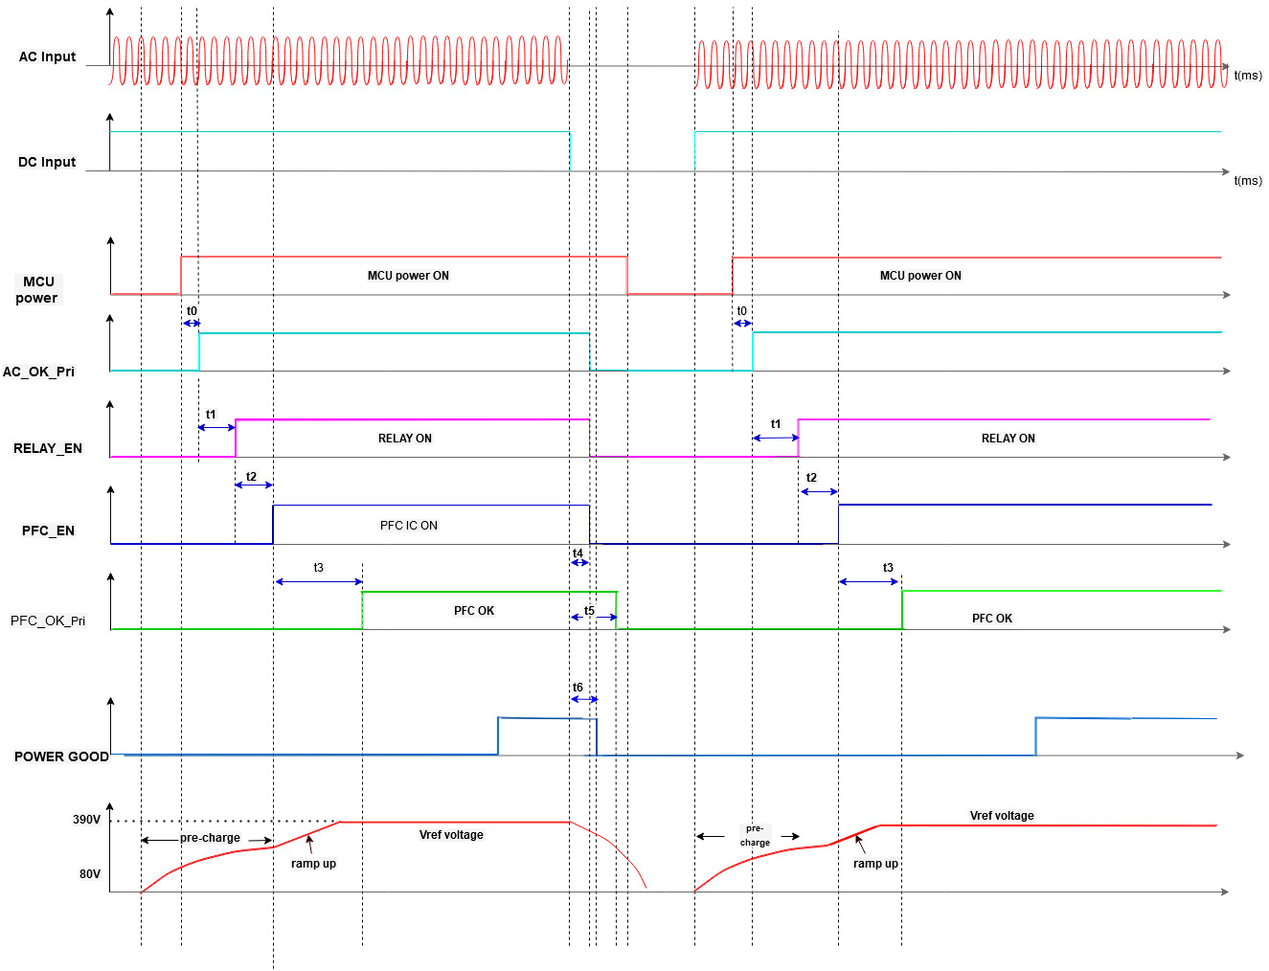

Name | Estimate Value | Optimized Value | description
t_p0 | 220 ms
t_p1 | 250 ms
t_p2 | 10 ms
t_p3 | 50 ms
V_AC_Min | 170 V
V_AC_Max | 295 V
V_DC_min | 250 V

SECONDARY Normal State Time SequenCE

Normal sequence
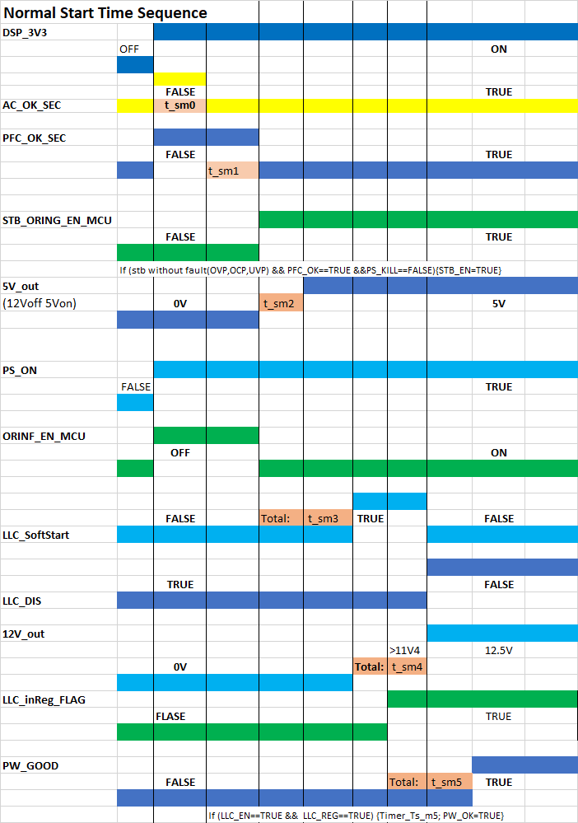

Name | Estimate Value | Optimized Value | Description
t_sm0 | 220 ms
t_sm1 | 310 ms
t_sm2 | 25 ms
t_sm3 | 250 ms
t_sm4 | 27 ms
t_sm5 | 200 ms

Summary fault flag: include Fan lock, 12Vmain Output OVP, UVP, OCP, OTP and PS_ON(Low), PFC_OK)SEC (High), Standby OVP, UVP, OCP.

Fault State Time Sequence -> AC_LOST

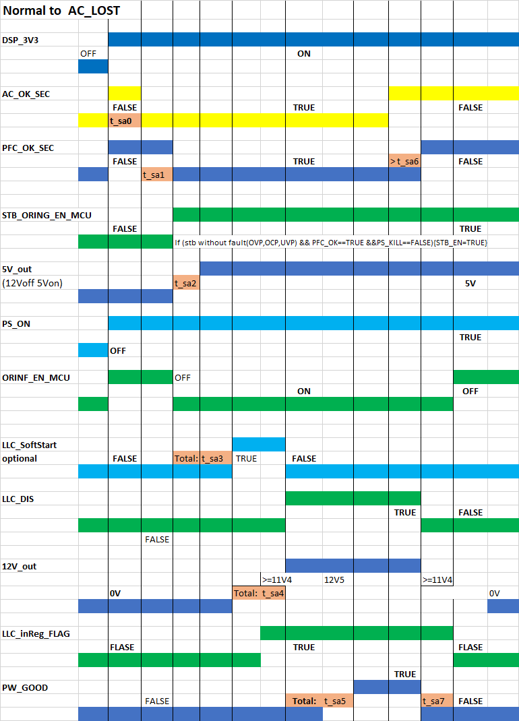

Name | Estimate Value | Optimized Value | Description
t_sa0 | 220 ms
t_sa1 | 310 ms
t_sa2 | 25 ms
t_sa3 | 250 ms
t_sa4 | 27 ms
t_sa5 | 200 ms
t_sa6 | 50 ms
t_sa7 | 5 ms

Fault PSON OFF > ON
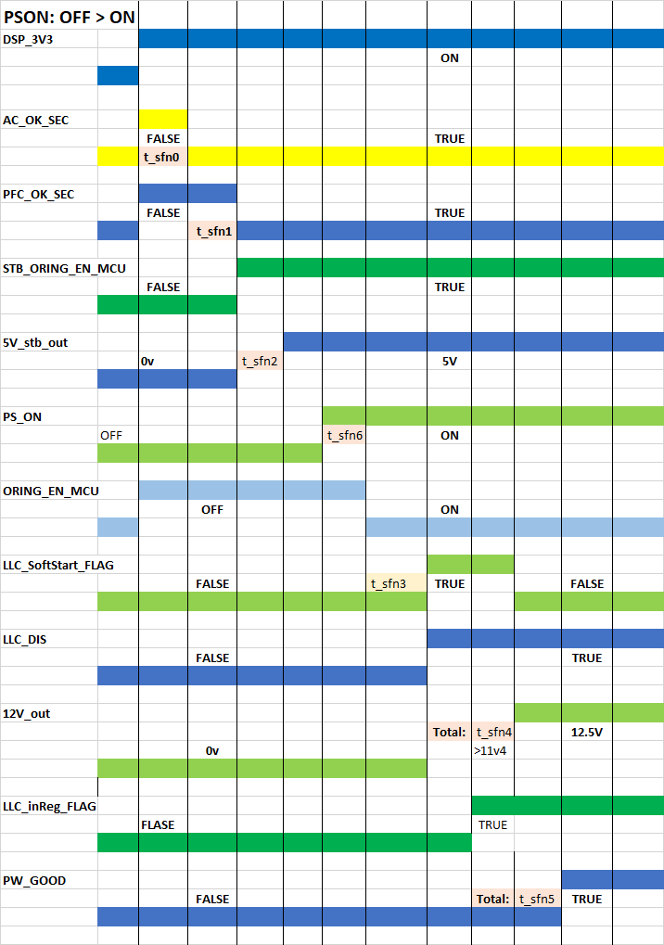

Name | Estimate Value | Optimized Value | Description
t_sfn0 | 220 ms
t_sfn1 | 310 ms
t_sfn2 | 25 ms
t_sfn3 | 250 ms
t_sfn4 | 27 ms
t_sfn5 | 200 ms
t_sfn6 | 20 ms

Fault State Time Sequence -> PS_ON to PS_OFF
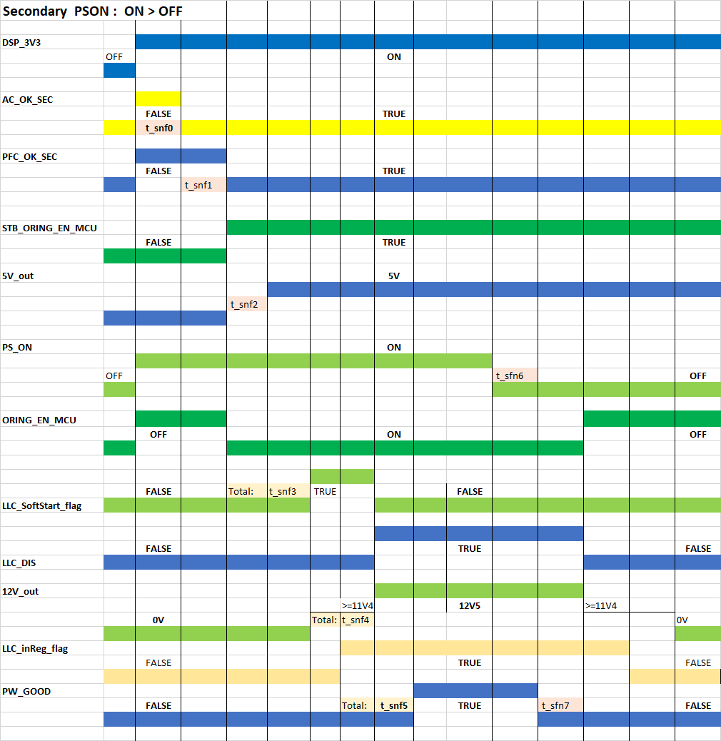

Name | Estimate Value | Optimized Value | Description
t_snf0 | 220 ms
t_snf1 | 310 ms
t_snf2 | 25 ms
t_snf3 | 250 ms
t_snf4 | 27 ms
t_snf5 | 200 ms
t_snf6 | 10ms
t_snf7 | 3ms

nORMAL TO fALse
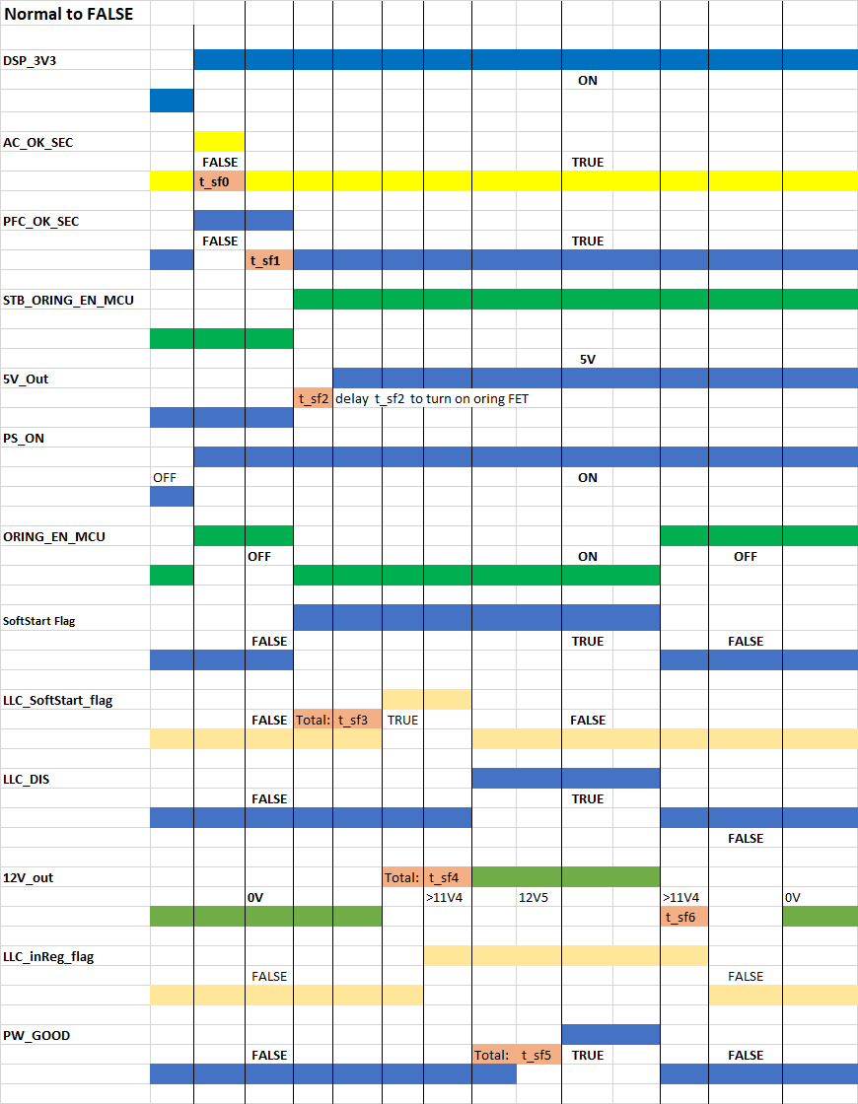

Name | Estimate Value | Optimized Value | Description
t_sf0 | 220 ms
t_sf1 | 310 ms
t_sf2 | 25 ms
t_sf3 | 250 ms
t_sf4 | 27 ms
t_sf5 | 200 ms
t_sf6 | 5 ms

OHERT CONTROL

PMbus communication
Reference: PS-1603-X01 PMBUS Spec.xlsx

RS232 communication

Setting
115200bps, N, 8, 1

Protocol
Reference: PS-1603-X01 RS232 Spec.xlsx

Bootloader

Optional Function ; Reference: PS-1603-X01 Bootloader.DOCX(tbd)

FAN Speed control
The maximum fan speed is limited to make sure the acoustical noise is less than 38.5 dB(A) at the condition of 100 VAC, 100 % load and 30 °C ambient temperature. Fan speed varies linearly with the temperature.
To keep the noise low the fan will be turned off under the following conditions:
1. in standby mode
2. when main output load is less than 10 %
3. when the ambient temperature is lower than a typical value 18 °C

LED
LED_STATUS | DISPLAY
No AC power available | LED OFF
AC Present / +5VSB on  (Main DC Output OFF) | BLINK_GREEN(1Hz)
Power Supply ON and OK | LED_ON

FW version rule
Bootloader version | Primary Side version | PSU Model Name | Secondary Side version
2 letter | 2 letter | 2 letters | 2 letters
05 | 0E | 6A | 03

Calibration
Reference: PS-1603-X01 CALIBRATION Spec.docx (TBD)

Black Box Fault Logging
When a fault condition occurs, the PSU must save certain status registers into non-volatile memory. The PSU must save a record of this data for the last five fault events. The history will be accessed via the MFR_PAGE command (E4h). If the history fills up, delete the oldest record and shift the remaining records down the queue following FIFO.
The MFR_POS_TOTAL for the Real-Time Data entry in black box fault logging (MFR_PAGE 0xFF) should not be cleared prior to PSU manufacturer shipment. All other black box data (MFR_PAGE 0x00-0xNN) should be cleared prior to PSU manufacturer shipment.

AWS Black Box Log PMBus CMD Table:
MFR_PAGE(0XE4)
MFR_PAGE |  | Refers to |  | Comments
0XFF |  | Real time data (default value) |  | When a fault condition occurs, the PSU must save certain status registers into non-volatile memory. The PSU must save a record of this data for the last five fault events. The history will be accessed via the MFR_PAGE command (E4h). If the history fills up, delete the oldest record and shift the remaining records down the queue following FIFO. Up to 17 black box events can be recorded.
0X00 |  | Fault history 1 (newest fault event)
0X01 |  | Fault history 2
0X02 |  | Fault history 3
0X03 |  | Fault history 4
0X04 |  | Fault history 5
0X05 ~0X10 |  | Option additional fault history locations
Sensors to save upon each fault event table
Command Number |  | Command Name |  | Command Number | Command Name
0x79 |  | STATUS_WORD |  | 0x8D | READ_TEMPERATURE_1 (Ambient)
0x7A |  | STATUS_VOUT |  | 0x8E | READ_TEMPERATURE_2 (Primary side)
0x7B |  | STATUS_IOUT |  | 0x8F | READ_TEMPERATURE_3 (Secondary side)
0x7C |  | STATUS_INPUT |  | 0x90 | READ_FAN_SPEED_1
0x7D |  | STATUS_TEMPERATURE |  | 0x91 | READ_FAN_SPEED_2
0x7E |  | STATUS_CML |  | 0x96 | READ_POUT
0x81 |  | STATUS_FANS_1_2 |  | 0x97 | READ_PIN
0x88 |  | READ_VIN |  | 0xD0 | MFR_FW_REVISION
0x89 |  | READ_IIN |  | 0xE5 | MFR_POS_TOTAL
0x8B |  | READ_VOUT |  | 0xE6 | MFR_POS_LAST
0x8C |  | READ_IOUT |  | 0xE7 | BMC_UNIX_TIMESTAMPS
MFR_POS_TOTAL(0XE5)
MFR_POS_TOTAL will respond with 4 bytes representing the total number of power on seconds the power supply has been turned on and delivering energy to the main output since it was manufactured in linear encoding following the PMBus specification for bit and byte order. The command is read only.
MFR_POS_LAST(0XE6)
MFR_POS_LAST will respond with 4 bytes representing the number of power on seconds the power supply has been turned on and delivering energy to the main output in linear encoding following the PMBus specification for bit and byte order. When the main output is not delivering energy, the PSU must hold the current value. The command is read only.
Log fetch
1. Write Byte to CMD 0X10 ->WRITE_PROTECT Disable -> 0x00
2. Write Byte to CMD 0XE4 -> Fault history 1 (newest fault event) -> 0x00
3. Read Black Box event log -> Read fault event 1 table, EX: read cmd 0x79~7E,..etc.
4. If you want to read other older fault events, change the value from item 2, for example: Fault history 2 -> 0x01
5. Write Byte to CMD 0XE4 -> 0XFF -> Real time data (default value). Expressed as the current information, there is no black box fault event.

